LIVER AMPK REGULATES TOTAL BODY LIPID ACCUMULATION ON A LCHF DIET BUT IS DISPENSABLE FOR INSULIN RESISTANCE

Katherine E. Kistler, Cody M. Cousineau, JeAnna R. Redd, Claire D. Gleason, Noura El Habbal, Molly ? Mulcahy, Detrick Snyder, Ken Inoki, Dave Bridges

Abstract

Introduction

Methods

* Generating liver-specific AMPK 1/2 knockout mice
  + Mice (C57BL6) were housed under controlled temperature and lighting (12-hour light/12-hour dark cycle) with access to water and normal chow (Lab Diet; 2.91 kcal/g; 5% fat, 24% protein, 2.7% sucrose, 32% starch). Animal use was performed in accordance with the Institute of Laboratory Animal Research ***Guide for the Care and Use of Laboratory Animals*** and approved by the University Committee on Use and Care of Animals at the University of Michigan. Mice that harbored homozygous, floxed alleles for both AMPK a1 and a2 were generated by S. Morrison (UT Southwestern Medical Center) as described 1 and shared by K. Inoki (University of Michigan Medical School)2. To produce liver-specific AMPK 1/2 knockout mice, at 70 days old these mice were injected through the tail vein with adeno-associated virus expressing either GFP (AAV8-TBG.PI.eGFP.WPRE. bGH) or Cre recombinase (AAV8.TBG.PPI.Cre.rBG) from a liver-specific TBG promoter (1.5 × 10 to 10 plaque-forming units per mouse).
* Making Liver lysates
  + After harvesting liver from mice, livers were placed in an Eppendorf tube in liquid nitrogen to freeze. Frozen tissue samples were cut using dry ice to 20-50 mg of tissue per sample. 20 uL/mg of RIPA buffer (from where?) was added to each sample and they were homogenized using Qiagen Tissue Lyser (3 min at 25Hz). Samples were centrifuged at 14,000 RPM at 4C for 10 min. 160 uL of supernatant was removed and 40 uL of ThermoFisher Scientific NuPAGE sample reducing agent (10x) and 200 uL of Fisher Scientific Tris-Glycine SDS sample buffer (2X) were added. Samples were heated with loading buffer at 85C for 2 mins and then snap frozen to -80˚ F.
* Western Blots
  + Liver lysate samples were boiled for 3 minutes at 85˚C using a heating block. 10 uL of samples were placed in a Fisher Scientific 15 well, 4-12% Tris-glycine, 1.0 MM mini protein gel in 1x SDS running buffer at 125 Volts until samples and ladder reached the bottom of the gel. Protein was transferred to nitrocellulose paper from the gel using a Bio-Rad Transfer Apparatus in 1X transfer buffer diluted from 10X with water and 20% methanol. Transfer occurred overnight at 35V. Nitrocellulose paper was stained for total protein using LI-COR Revert Total Protein Stain for 5 minutes and rinsed twice in LI-COR revert wash solution. The blot was scanned for total protein using the LI-COR (model?). Nitrocellulose was then rinsed in LI-COR revert reversal solution for 5 minutes and then rinsed in 2% BSA (2g BSA in 100ml TBST) for 1 hour. The blots were incubated in primary antibody for greater than 1 hour and washed every 5 minutes for 15 minutes using TBST. The primary antibodies were: total AMPKalpha, AMPKalpha phosphorylated at Thr172, total ACC, ACC phosphorylated at Ser79, total FAS, total S6, S6 phosphorylated at ____, total S6K, S6K phosphorylated at ___, other antibodies? (All from Cell Signaling Technology). Blots were incubated with 10,000x secondary antibody (list both of them) for 45 minutes and washed every 5 minutes for 15 minutes with TBST and rinsed with double distilled water. Blots were scanned using LI-COR (model) and normalized using total revert stain.
* Ketone body assay
  + Ketone bodies from serum were analyzed using the Wako Diagnostics ketone bodies R1 and R2 kit. 4 uL of each control sample and 1 uL of each ketogenic diet sample were pipet into a 96 well plate. 270 uL of R1 was added to each well and incubated for 5 minutes at 37˚C. Next, 90 uL of R2 were added to each well and then placed in the plate reader at 37˚C.
* Food Intake
  + CD and KD were placed in shallow jars with holes in the lid allowing for ad libitum food access. The lid was essential to prevent the food from spilling out of the jar and for accurate food measurements. Jars with food were weighed and refilled every other day.
* Body composition measurements using MRI
  + The mice were weighed on a scale weekly to measure body weight. Fat and lean tissue mass was measured in vivo using Echo MRI 1100 weekly. Measurements were taken at approximately the same time daily to account for fluctuations in body weight throughout the day.
* Serum collection
  + Mice were anesthetized using isoflurane and blood was collected using retro-orbital bleeding. After collection, samples were centrifuged at 4˚C for ____ minutes. The top layer (serum) was transferred to another tube and frozen at -80 ˚C.
* Liver Histology
* Triglyceride Assay
* Insulin tolerance tests
  + Mice were fasted for 6 hours and then injected with 0.75 U/kg of lean body mass of insulin into the intraperitoneal cavity. Blood glucose was measured from the tail vein at time 0, 15, 30, 45, 60, 75, 90, 105 and 120 minutes after injection using a glucometer (brand?).
* Sacrifice mice
  + Mice were sacrificed using isoflurane and cervical dislocation. The tissues were harvested immediately upon sacrifice, weighed and placed in liquid nitrogen. The tissues were then stored at -80 ˚C.
* Statistical analysis
  + Insulin tolerance tests were analyzed using a mixed linear model using the time points as ordinate values to test for an interaction of the treatment/genotype.

Results

* Experimental Design
  + At the start of the experiment, mice were raised on a normal chow diet (Lab Diet; 2.91 kcal/g; 5% fat, 24% protein, 2.7% sucrose, 32% starch). At 70 days old, mice were injected with either AAV-TBG-GFP or AAV-TBG-CRE to produce liver-specific controls and knockouts, respectively. The mice continued to consume normal chow for two weeks post injection at which point they were placed on either a ketogenic (KD) (6.4 kcal/g; 85% fat, 15% protein, 0% sucrose, 0% starch) or matched control diet (CD) (3.8 kcal/g; 10% fat, 15 protein, 0% sucrose, 75% starch). One week later, blood samples were taken using retro-orbital bleeding. Another week later insulin tolerance tests were performed. Two weeks later mice were sacrificed and tissues were collected. Body composition (weight, fat mass and lean mass) and food intake was measured weekly from the start of injections until sacrifice.
* AMPK effectively knocked out and confirmed using Western Blots
  + We used western blots to ensure that AMPK 1/2 subunits were knocked out in the liver and to observe any changes in lipogenic and beta-oxidation genes. Western Blots of liver lysates showed approximately __% of males that received AAV-TBG-CRE injections had AMPK effectively knocked out. We included only the males that had AMPK knocked out for the remainder of the study (Figure 2A). Surprisingly, females that received the received AAV-TBG-CRE injections did not show an efficient knockout of AMPK 1/2 (Figure 2A). Similarly, pACC was not down regulated in the females that received the CRE injections (Figure 2A). For this reason, we investigated the males for the remainder of the experiments.
  + pACC, a downstream target of AMPK and lipogenic gene, was reduced in males that received AAV-TBG-CRE injections which confirmed the knockout (Figure 2A). This also indicates there may also be an increase in lipogenesis in the KO mice. pACC was also reduced on a KD relative to the CD for both treatment groups (Figure 2A). This also indicates there may be an increase in lipogenesis on the ketogenic diet. Another lipogenic gene, FAS, was found to decrease on a ketogenic diet but was not different between treatment groups (Figure 2B) suggesting FAS was not driving any observed changes in the KO mice. ACLY, another lipogenic gene, was found to _______ (Figure 2B)
  + Because of the known role of AMPK in regulating mTOR signaling and lipogenesis (citation) we observed downstream targets of mTOR such as total S6, pS6, total S6K and pS6K. We found that mTOR signaling was not different between diet or treatment groups (Figure 2B).
  + Overexpression of AMPK in the liver has been shown to increase beta-oxidation3, so we next investigated changes in beta-oxidation genes.
  + (Need to look at these) The beta-oxidation genes, CPT1, MCAD and ACAD were found to _______ (Figure 2C)
  + (Need to look at this) Others have shown that sip7a1, a regulator of bile acid reuptake, decreases on a ketogenic diet. We found that sip7a1 _________ (Figure 2C?)
* Ketone Levels Increase on Ketogenic Diet and AMPK had No Effect on Ketone Production
  + Some have suggested the ketone production may be the key driver of physiological changes on a ketogenic diet (citation). Additionally, others have shown that overexpression of AMPK in the liver leads to increases in ketone production3. Our data shows that serum ketone body levels increased in mice on a ketogenic diet but were not different between KO and WT mice (Figure 3A). This confirms any observed changes between treatment groups were not due to differences in ketone production. Both KO and WT males fed a control diet did not increase ketone body production (Figure 3A).
  + We looked at food intake to confirm any observed changes between KO and WT were not due to differences in caloric intake. We found there were no differences in caloric intake between KO and WT mice on either diet (Figure 3B). Mice on a KD, however, consumed more calories per day than mice on a CD (Figure 3B).
* KO mice on a KD have more gonadal and liver adipose tissue
  + In agreement with previous findings4, there was no difference in body weight, fat mass or lean mass between treatment groups on either diet (Figure 4 A, B and C). Both KO and WT mice on a ketogenic diet gained significantly more body weight than mice on a control diet (Figure 4A) which was due to an increase in fat mass (Figure 4B). There were no differences in fat mass between KO and WT mice on a ketogenic diet (Figure 4B). Consistent with no observed changes in lean mass between groups, the gastrocnemius and quadriceps weights were the same between KO and WT mice on both diet groups at the time of sacrifice (Figure 4D,E). Consistent with the change in fat mass over four weeks, inguinal adipose tissue weight at the time was sacrifice was higher in those on a ketogenic diet, but again not different between treatment groups (Figure 4F). Gonadal adipose tissues (GWAT), however, did show a treatment difference with KO males having an increase in GWAT compared to WT males on a ketogenic diet (Figure 4G). This difference was not seen between KO and WT on a control diet.
  + Consistent with the observed differences in GWAT between KO and WT mice on a ketogenic diet, KO mice on a ketogenic diet appeared to have increased liver fat accumulation compared to WT on a ketogenic diet (Figure 5A). Additionally, the observed increases in fat mass on a ketogenic diet were also seen in the male livers on a ketogenic diet relative to the control diet (Figure 5A). There were no differences in liver fat mass seen between treatment groups on a control diet (Figure 5A). Need to quantify liver TGs and put that here (Figure 5B).
* AMPK 1/2 KO does not impact insulin sensitivity on a Ketogenic Diet
  + Despite the increases in liver and gonadal adipose tissue in KO mice on a ketogenic diet, there were no differences in fasting blood glucose or insulin sensitivity between treatment groups on a ketogenic diet (Figure 6A). There were differences in fasting glucose and insulin sensitivity between diet groups in that both KO and WT ketogenic diet mice had higher glucose levels and a larger drop with subsequent increase in blood glucose compared to mice fed a control diet (Figure 6A).

Discussion

* + “Previously found, genetic deletion of alpha a1, a2, or b2 isoforms in mice has little effect on liver AMPK activity 5,6,7. By contrast, germline deletion of AMPK b1 [65] leads to a large reduction in liver AMPK activity (_95%), indicating that the b1 subunit is essential for maintaining the AMPK heterotrimer in the liver. mice with a liver-specific knockout of AMPK a2 were hyperglycemic and had elevated HGP relative to controls 8. However, mice lacking both AMPK a1 and a2 subunits in the liver (which led to no detectable liver AMPK activity) did not result in hyperglycemia or increases in HGP. In addition, AICAR continued to suppress HGP in liver-specific AMPKa1a2 KO mice suggesting that the glucose lowering-effects of AICAR are independent of AMPK 9,10,4,11. liver-specific AMPK a1a2 null mice have reduced mitochondrial content, mitochondrial respiration, and oxidative capacity, demonstrating that AMPK is required for maintenance of hepatic of mitochondrial function 4. Importantly, this appears to have functional consequences because, during fasting, a time of heavy ATP demand because of gluconeogenesis, there are large reductions in ATP levels in liver-specific AMPK a1a2 null mice 11. In addition to reductions in mitochondrial content, this impairment in mitochondrial function may also be attributed to defects in mitophagy and mitochondrial fission. Reductions in liver AMPK activity in AMPK b1-knockout hepatocytes reduces the phosphorylation of ACC and leads to reductions in FAO and increases in lipogenesis 12. Overexpression of AMPK a1 in the liver reduces lipogenic gene expression, liver triglyceride content, and hepatic steatosis in hyperlipidemic, type 2 diabetic rats in vivo 13, and reduces triglyceride and intracellular lipid accumulation while increasing CPT1 expression (increasing fatty acid clear-ance via mitochondrial FAO) when overexpressed in hepatocytes in vitro 14 “ 15

Author Contributions

Acknowledgements

References

1. Nakada D, Saunders TL, Morrison SJ. Lkb1 regulates cell cycle and energy metabolism in haematopoietic stem cells. *Nature*. 2010;468(7324):653-658. doi:10.1038/nature09571

2. Kazyken D, Magnuson B, Bodur C, et al. AMPK directly activates mTORC2 to promote cell survival during acute energetic stress. *Sci Signal*. 2019;12(585). doi:10.1126/scisignal.aav3249

3. Foretz M, Ancellin N, Andreelli F, et al. Short-term overexpression of a constitutively active form of AMP-activated protein kinase in the liver leads to mild hypoglycemia and fatty liver. *Diabetes*. 2005;54(5):1331-1339. doi:10.2337/diabetes.54.5.1331

4. Hasenour CM, Ridley DE, Hughey CC, et al. 5-Aminoimidazole-4-carboxamide-1-β-D-ribofuranoside (AICAR) effect on glucose production, but not energy metabolism, is independent of hepatic AMPK in vivo. *J Biol Chem*. 2014;289(9):5950-5959. doi:10.1074/jbc.M113.528232

5. Viollet B, Andreelli F, Jørgensen SB, et al. The AMP-activated protein kinase α2 catalytic subunit controls whole-body insulin sensitivity. *J Clin Invest*. 2003;111(1):91-98. doi:10.1172/JCI16567

6. Jørgensen SB, Viollet B, Andreelli F, et al. Knockout of the α2 but Not α1, 5′-AMP-activated Protein Kinase Isoform Abolishes 5-Aminoimidazole-4-carboxamide-1-β-4-ribofuranoside- but Not Contraction-induced Glucose Uptake in Skeletal Muscle. *J Biol Chem*. 2004;279(2):1070-1079. doi:10.1074/jbc.M306205200

7. Steinberg GR, O’Neill HM, Dzamko NL, et al. Whole body deletion of AMP-activated protein kinase β2 reduces muscle AMPK activity and exercise capacity. *J Biol Chem*. 2010;285(48):37198-37209. doi:10.1074/jbc.M110.102434

8. Andreelli F, Foretz M, Knauf C, et al. Liver adenosine monophosphate-activated kinase-α2 catalytic subunit is a key target for the control of hepatic glucose production by adiponectin and leptin but not insulin. *Endocrinology*. 2006;147(5):2432-2441. doi:10.1210/en.2005-0898

9. Foretz M, Hébrard S, Leclerc J, et al. Metformin inhibits hepatic gluconeogenesis in mice independently of the LKB1/AMPK pathway via a decrease in hepatic energy state. *J Clin Invest*. 2010;120(7):2355-2369. doi:10.1172/JCI40671

10. Miller RA, Chu Q, Xie J, Foretz M, Viollet B, Birnbaum MJ. Biguanides suppress hepatic glucagon signalling by decreasing production of cyclic AMP. *Nature*. 2013;494(7436):256-260. doi:10.1038/nature11808

11. Hasenour CM, Ridley DE, James FD, et al. Liver AMP-activated protein kinase is unnecessary for gluconeogenesis but protects energy state during nutrient deprivation. *PLoS One*. 2017;12(1). doi:10.1371/journal.pone.0170382

12. Dzamko N, van Denderen BJW, Hevener AL, et al. AMPK β1 deletion reduces appetite, preventing obesity and hepatic insulin resistance. *J Biol Chem*. 2010;285(1):115-122. doi:10.1074/jbc.M109.056762

13. Seo E, Park EJ, Joe Y, et al. Overexpression of AMPKα1 ameliorates fatty liver in hyperlipidemic diabetic rats. *Korean J Physiol Pharmacol*. 2009;13(6):449-454. doi:10.4196/kjpp.2009.13.6.449

14. Zhang HA, Yang XY, Xiao YF. AMPKα1 overexpression alleviates the hepatocyte model of nonalcoholic fatty liver disease via inactivating p38MAPK pathway. *Biochem Biophys Res Commun*. 2016;474(2):364-370. doi:10.1016/j.bbrc.2016.04.111

15. Day EA, Ford RJ, Steinberg GR. Feature Review AMPK as a Therapeutic Target for Treating Metabolic Diseases The Role of AMPK in Immune Cells. Published online 2017. doi:10.1016/j.tem.2017.05.004

Figure/Table Legends

* **Figure 1.** Experimental design of AMPK 1/2 KO mice on a ketogenic diet.

Mice were raised on a normal chow diet (Lab Diet; 2.91 kcal/g; 5% fat, 24% protein, 2.7% sucrose, 32% starch). At 70 days old (week -2), mice were injected with either AAV-TBG-GFP or AAV-TBG-CRE to produce liver-specific controls and knockouts, respectively. The mice continued to consume normal chow for two weeks post injection at which point they were placed on either a ketogenic (KD) (6.4 kcal/g; 85% fat, 15% protein, 0% sucrose, 0% starch) or matched control diet (CD) (3.8 kcal/g; 10% fat, 15 protein, 0% sucrose, 75% starch) (week 0). One week later (week 1), blood samples were taken using retro-orbital bleeding. Another week later (week 2) insulin tolerance tests were performed. Two weeks later (week 4) mice were sacrificed and tissues were collected.

* Figure 2. Western Blots for 1/2 AMPK KO and WT mice on either a KD or CD.
  + ***Figures not from illustrator**
  + A)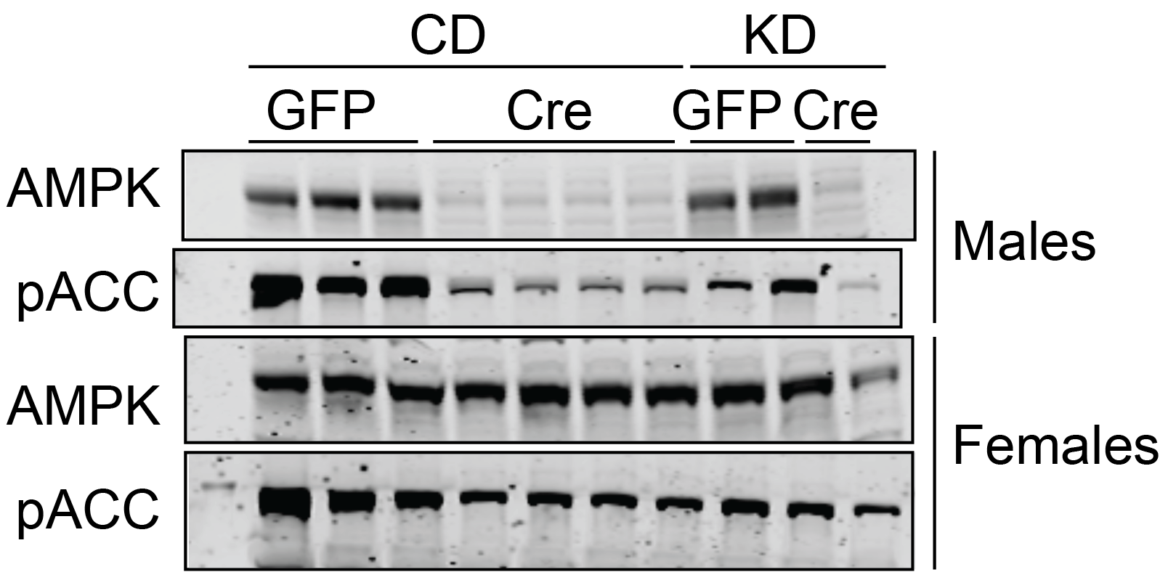
  + B)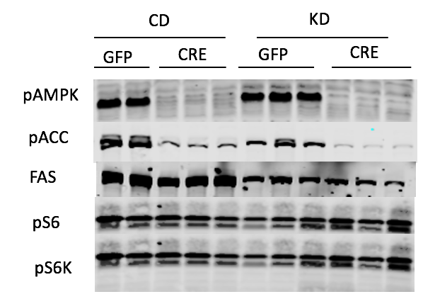
* Figure 3.
  + A. Ketones
  + B. Food Intake
* **Figure 4.** Liver-AMPK Knockout (a1a2lox/lox+Albcre) mice on a ketogenic diet have more gonadal and liver adiposity but exhibit no other changes in body composition compared to wild type (a1a2lox/lox) mice.

**A)** Changes in body weight of KO and WT male and female mice on a KD and CD from the time of injection (-2 weeks) to the time of sacrifice (4 weeks). At week 0 mice were started on either the ketogenic or control matched diet. **B)** Changes in fat mass of KO and WT male and female mice on a KD or CD measured weekly in vivo using using Echo MRI 1100. **C)** Changes in lean mass of KO and WT male and female mice on a KD or CD measured in vivo weekly using Echo MRI 1100. **D)** Gastrocnemius weight of KO and WT male and female mice on a KD and CD measured at the time of sacrifice (week 4). **E)** Quadriceps weight of KO and WT male and female mice on a KD and CD measured at the time of sacrifice (week 4). KO = knockout a1a2lox/lox+Albcre mice, WT = Wild type (a1a2lox/lox) mice, KD = ketogenic diet, CD = control diet.

* Figure 5. Liver fat changes
  + A. Histology
  + B. TGs
* Figure 6.
  + A. Insulin Tolerance Tests (ITT) was performed in AMPK 1/2 KO or WT mice by intraperitoneal insulin injection. Blood glucose was monitored over the course of 120 minutes after insulin injection.